Class #4 Workbook Name ___________________

- Name at least 3 reasons why signs use mostly graphics, instead of words:

- What does a black sign mean?
- Draw a picture of the pennant shaped sign, what it means, and what side of the road you find it on:

- Traffic Control Planners use signs to tell you:
What _____________ ______
What to __________ _______
Where _________ _________

Explain the color of the signs:
- Green Sign:

- Brown Sign:

- Blue Sign:

- Route Signs are _________________________ ____________________________ or ____________________ and they can be in multiple different colors.

Interstate Numbers:
- North & South are _________ numbers
- East & West are ________ numbers
- Freeways with ____________ numbers are telling you it is in offshoot from the main freeway.

Streets & Avenues:
- North & South are: ______________________
- East & West are: ________________________

Explain the signs:
- Pink Sign:

- Orange Sign & What is special about it:

- Draw a pentagon shaped sign and its meaning:

- Regulatory Signs mean ____________________________________________________________
- Where do you stop at a stop sign?

- Yield Sign:

- Draw a picture of a Cross Buck and what does it mean?

- The Speed Limit Sign is a ________________________________ sign that is a ________________ shape.
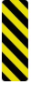
- Speed limits take effect as you __________________________ _______ _________.
- The Speed Limit on Streets in cities and towns is ________ mph unless otherwise posted.
- What does this mean?

- The Basic Speed Law says you ___________________ than is safe or prudent for the existing conditions regardless of the speed limit.
- Traffic Circle: Yield to those ___________________________________ and you always turn _________ .

Draw a picture and explain the Arrows:
- Right Red Arrow
- Right Yellow Arrow
- Right Green Arrow
- Left Red Arrow
- Solid Yellow Light
- Left Flashing Yellow Arrow
- Left Green Arrow

- The Point of No Return means:

- What do you think you might have to do at a stale green light?
- When the electricity is out, treat the intersection like it is a ________________________________.
- You must listen to:
1.
2.
3.

- Draw a picture of a construction flagger and label what his/her arm signals mean:

- After stopping and checking for traffic, you can turn left on a red light if you are entering a ______________.

- When can you drive across the crosswalk when a pedestrian is in the road in WA?
- What is the difference between the white and the yellow lines in the middle of the road?
- Double yellow lines that are 18” apart means no passing & _______________________________
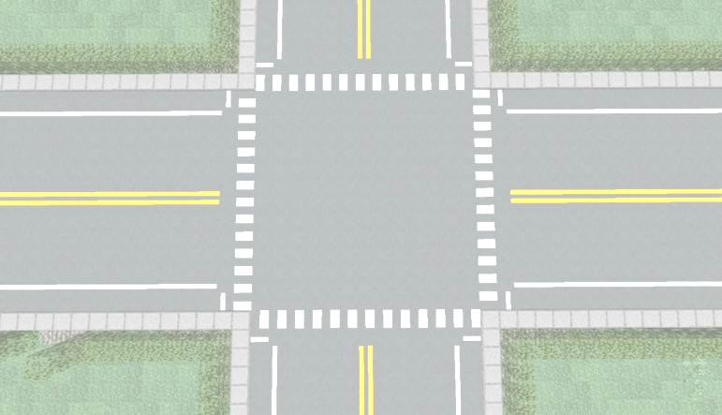
- The solid white line on the right means:
- White arrows painted on the road mean:

- Give some examples of who gets to go:

- Yield to the people on your __________.

- The law says who must ___________________ It does not give absolute right of way.
- 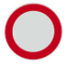This red & white sign means _________________________________________________________

